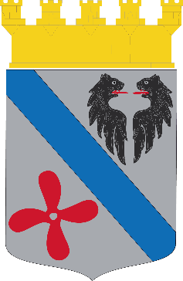

**Motala**

2020-06-02

***Dear Mr Andrejs and Mrs Marina,***

*Thank you for your invitation to the celebration of your 745 years!*

*We would certainly like to celebrate with you, but covid-19 does not aloud us to come.*

*We hope next year will gave us the opportunity tu visit Daugavpils, and the pleasure to welcome some visiters from Daugavpils!*

*Finally we are grateful for your hospitality from last year, and we would lika to give a special thanks to the guide, Jolanta Reča-Lāže. She really did her best to make our visit perfect.*

*I hope that you will have very nice days during the 745th celebration festival!*

*Yours sincerely,*

**

*Nils-Ingvar Graan*

*Lord Mayor of Motala municipality*